**Capstone Project - The Battle of Neighborhoods (Week-1)**

**Opening a Restaurant in Bucharest**

**1. Introduction/Business Problem**

**1.1 Background**

Bucharest is the capital and largest city of Romania. It is located in the southeast of the country, at coordinates: 44°25′57″N 26°06′14″E, north of the Danube River and the Bulgarian border.

Bucharest occupied the **109th** place in 2019 for **quality of life** by the Mercer international surveys. Bucharest, at number 109, ranks low in the European list but better than other European cities such as Sofia (116th) and Belgrade (139th).

Bucharest is the center of the Romanian economy and industry, accounting for around 24% (2017) of the country's GDP and about one-quarter of its industrial production, while being inhabited by 9% of the country's population.

Bucharest has **2 million** populations and consists of **6 sectors**. Neighborhoods and populations in sectors are as below:

1. **Sector 1** *(population 227,717):* Dorobanți, Băneasa, Aviației, Pipera, Primăverii, Dămăroaia, Grivița
2. **Sector 2** *(population 357,338):* Pantelimon, Colentina, Iancului, Tei, Floreasca, Moșilor, Obor, Fundeni,
3. **Sector 3** *(population 399,231):* Vitan, Dudești, Titan, Centrul Civic, Dristor, Lipscani
4. **Sector 4** *(population 300,331):* Berceni, Olteniței, Progresul, Văcărești, Tineretului
5. **Sector 5** *(population 288,690):* Rahova, Ferentari, Giurgiului, Cotroceni, 13 Septembrie, Dealul Spirii
6. **Sector 6** *(population 371,060):* Giulești, Crângași, Drumul Taberei, Militari, Grozăvești(Regie), Ghencea

**1.2. Problem Statement**

In this project, we will investigate that if there is any good location in Bucharest for opening a restaurant.

**1.3. Interest**

Anyone who wants to open a new venue in any location may be interested in this project by customizing and changing the search criteria according to their needs.

**2. Data**

**2.1 Data sources**

We can list the data as below for the chosen problem statement:

* We get the neighborhood data of Bucharest from Wikipedia
* We use python geocoder library to get geographical coordinates of neighborhoods
* We use **Foursquare API venues method** to get ranks and likes of restaurants by given venue id.
* We use **Foursquare API** **venues explore** method to get the venues of given neighborhoods of Bucharest.

**2.2 Feature Selection and Data Usage**

We will use neighborhood location values to analyze Bucharest geography.

Folium library of python will be used to draw maps by using given latitude and longitudes of neighborhoods. Selected features will be as below

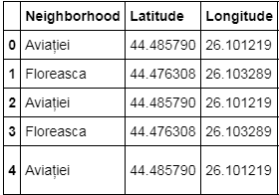

We will use populations of neighborhoods which has a large population and a new restaurant will be good for the neighborhood and the business.

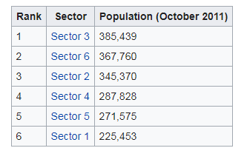 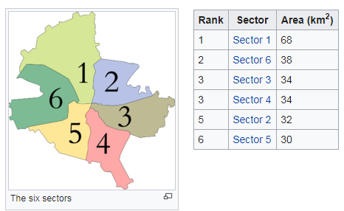

We will also classify neighborhoods by using venues distribution and counts. In this way, we will find similarities of neighborhoods which will help us to choose location for opening a new restaurant. Similar structured neighborhoods may handle same type of venue.

